**1DAILY ONLINE ACTIVITIES SUMMARY**

|  |  |  |  |  |  |  |  |  |
| --- | --- | --- | --- | --- | --- | --- | --- | --- |
| **Date:** | **19-7-2020** | | | | | **Name:** | **poojashree** | |
| **Sem & Sec** | **8th sem A sec** | | | | | **USN:** | **4al16cs065** | |
| **Online Test Summary** | | | | | | | | |
| **Subject** | |  | | | | | | |
| **Max. Marks** | |  | | **Score** | | |  | |
| **Certification Course Summary** | | | | | | | | |
| **Course** | **Introduction to cyber security** | | | | | | | |
| **Certificate Provider** | | | **Great learning academy** | | **Duration** | | | **5.5hr** |
| **Coding Challenges** | | | | | | | | |
| **Problem Statement:**  **Program to calculate sum of the series** | | | | | | | | |
| **Status:completed** | | | | | | | | |
| **Uploaded the report in Github** | | | | | **yes** | | | |
| **If yes Repository name** | | | | | **Poojashree** | | | |
| **Uploaded the report in slack** | | | | | **yes** | | | |

**Online test**

**----------no marks -----------**

**Certification course**

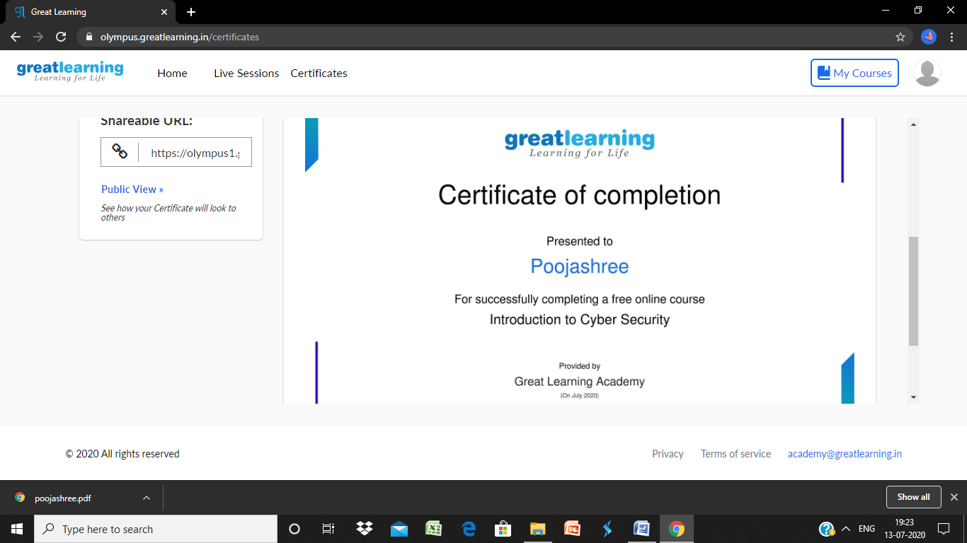

**Coding**

**Program 1**

**#include <stdio.h>**

**//function for creating the sum of the**

**//series up to Nth term**

**int series_sum(int n)**

**{**

**return ((n * (n + 1) * (2 * n + 4)) / 12);**

**}**

**int main()**

**{**

**int n;**

**printf("Series:1+(1+2+)+(1+2+3)+...+(1+2+3+...+n)\n");**

**printf("Want some up to N terms?\nEnter the N term:");**

**scanf("%d", &n);**

**printf("Sum is:%d", series_sum(n));**

**return 0;**

**}**